

**Come join us for our annual Spring Fest celebration. Spring Fest will be on Friday, May 16th from 5pm-7pm. We will have carnival games with prizes, bounce houses, balloon twisters, a photo selfie station, Cake Walk, The Give and Get event, and so much more. This event will be rain or shine at Neff Elementary. This is not a drop off event. All students must be accompanied by a responsible adult.** **Pre-Order your tickets below!**

**Wristbands** for the event are for children only. They will be $5 per wristband and families with 4 or more children will be capped at $20.

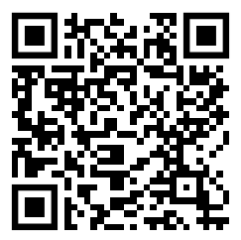**Pre-sale Tickets** for the Give and Get Event will be 6 tickets-$5, 14 tickets-$10, 30 tickets-$20. Tickets at the door will be 1 ticket-$1.

**Volunteers still needed**. Please scan the QR code to sign up to help. We need many helpers to make this event successful.



Please return bottom portion with cash or check by May 15th in a sealed envelope labeled Spring Fest Tickets to receive the pre-sale discount. If you are paying via Venmo please send in this form with student/ticket information in a sealed envelope labeled Spring Fest Tickets. Tickets will be delivered to the student prior to the event. All Sales are final.

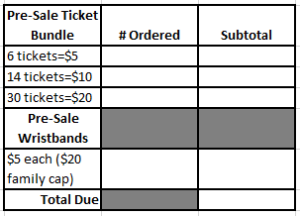Student’s Name: _______________________________________

Grade (circle one): K 1 2 3 4

Teacher’s Name: ______________________________________

*If you have multiple children at Neff, please indicate which child to

Send tickets home with: ________________________________

Payment method: Cash/Venmo/Check#: ______­­____________

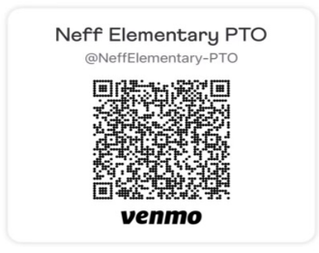*\*Please make checks payable to ‘Neff PTO”*

*Return checks will incur a $36 fee*